Explaining changes in foot morphology during gait through 4D scanning and shape modeling

Abstract will go here.

# Introduction

# Methods

## Subjects

A total of 30 healthy subjects (15 men and 15 women, ages 23.1 $±$ 3.7) participated in this study. Subjects were recruited in a stratified sample into one of six groups (5 subjects per group) to maximize variance in population foot length. Height was used as the grouping factor since height is well correlated to foot length (Giles and Vallandigham 1991). The general population may not know offhand their exact foot length and shoe size varies by manufacturer and does not correspond directly to foot length. Groups consisted of 5th-35th, 35th-65th, and 65th-95th height percentiles for each sex. Height percentile values were taken from the ANSUR II survey (Gordon et al. (2014)) and converted to imperial units as it was expected most subjects would report their height in imperial units. Population recruitment groups are summarized in tbl. 1.

Prior to recruitment, subjects completed a prescreening survey to ensure they were adequately healthy (ACSM guidelines [REF]) and between the ages of 18-65. Subjects provided their sex and height, and were only enrolled in the study if their population group was not fully enrolled.

Table 1: Enrollment groups based on reported height. 5 subjects were enrolled in each group

|  |  |  |  |
| --- | --- | --- | --- |
| Sex | 5th-35th percentile Height | 35th-65th percentile Height | 65th-95th percentile Height |
| Female | 4’11“-5’3” | 5’3“-5’5” | 5’5“-5’8” |
| Male | 5’4“-5’8” | 5’8“-5’11” | 5’11“-6’2” |

## Experimental Procedures

The experimental protocol was approved by the University of Colorado Institutional Research Board. Procedures were explained to each subject and written consent was obtained prior to participation. Subjects’ height and weight were measured with a tape measure and scale, respectively. Subjects’ foot length, foot width, and arch length were measured with a Brannock device (The Brannock Device Company, Liverpool, NY) in centimeter scale, the most granular measurement available. Foot width measured with the Brannock device was converted from a size (e.g. A, B, C, D, E) to a linear measurement in centimeters using the following formula (The Brannock Device Company, Liverpool, NY):

$$w_{cm}=(3+(w_{offset}*3/16)+(l*(1/2.54)-8)*3/8)*2.54$$

where $w_{cm}$ is the foot width in centimeters, $w_{offset}$ is the foot width size offset from standard size D, and $l$ is the foot length in centimeters.

Six Intel RealSense D415 Depth Cameras (Intel, Santa Clara, CA) were placed and calibrated around a custom-built level treadmill in the University of Colorado Boulder Locomotion Laboratory, as shown in fig. 1. The DynaMo software package was used to capture depth images of the right foot at 90 frames-per-second while subjects walked on the treadmill (Boppana and Anderson 2019). For each captured frame, the depth images were converted into a single point cloud using the known camera intrinsic and extrinsic properties (Boppana and Anderson 2019).

Subjects walked on the treadmill set at an average walking pace of 1.4 m/s (Browning et al. 2006). Subjects wore a black sock on their left foot and left their right foot bare to aid in object identification described later. Subjects first walked for one minute to warm-up and fall into a natural cadence. The operator then collected 10 seconds of data to capture approximately 10 steps. The data were reviewed to ensure the subject stayed in frame from heel-strike to toe-off during capture. If needed, the subject’s placement was shifted and data was collected again, up to two times.

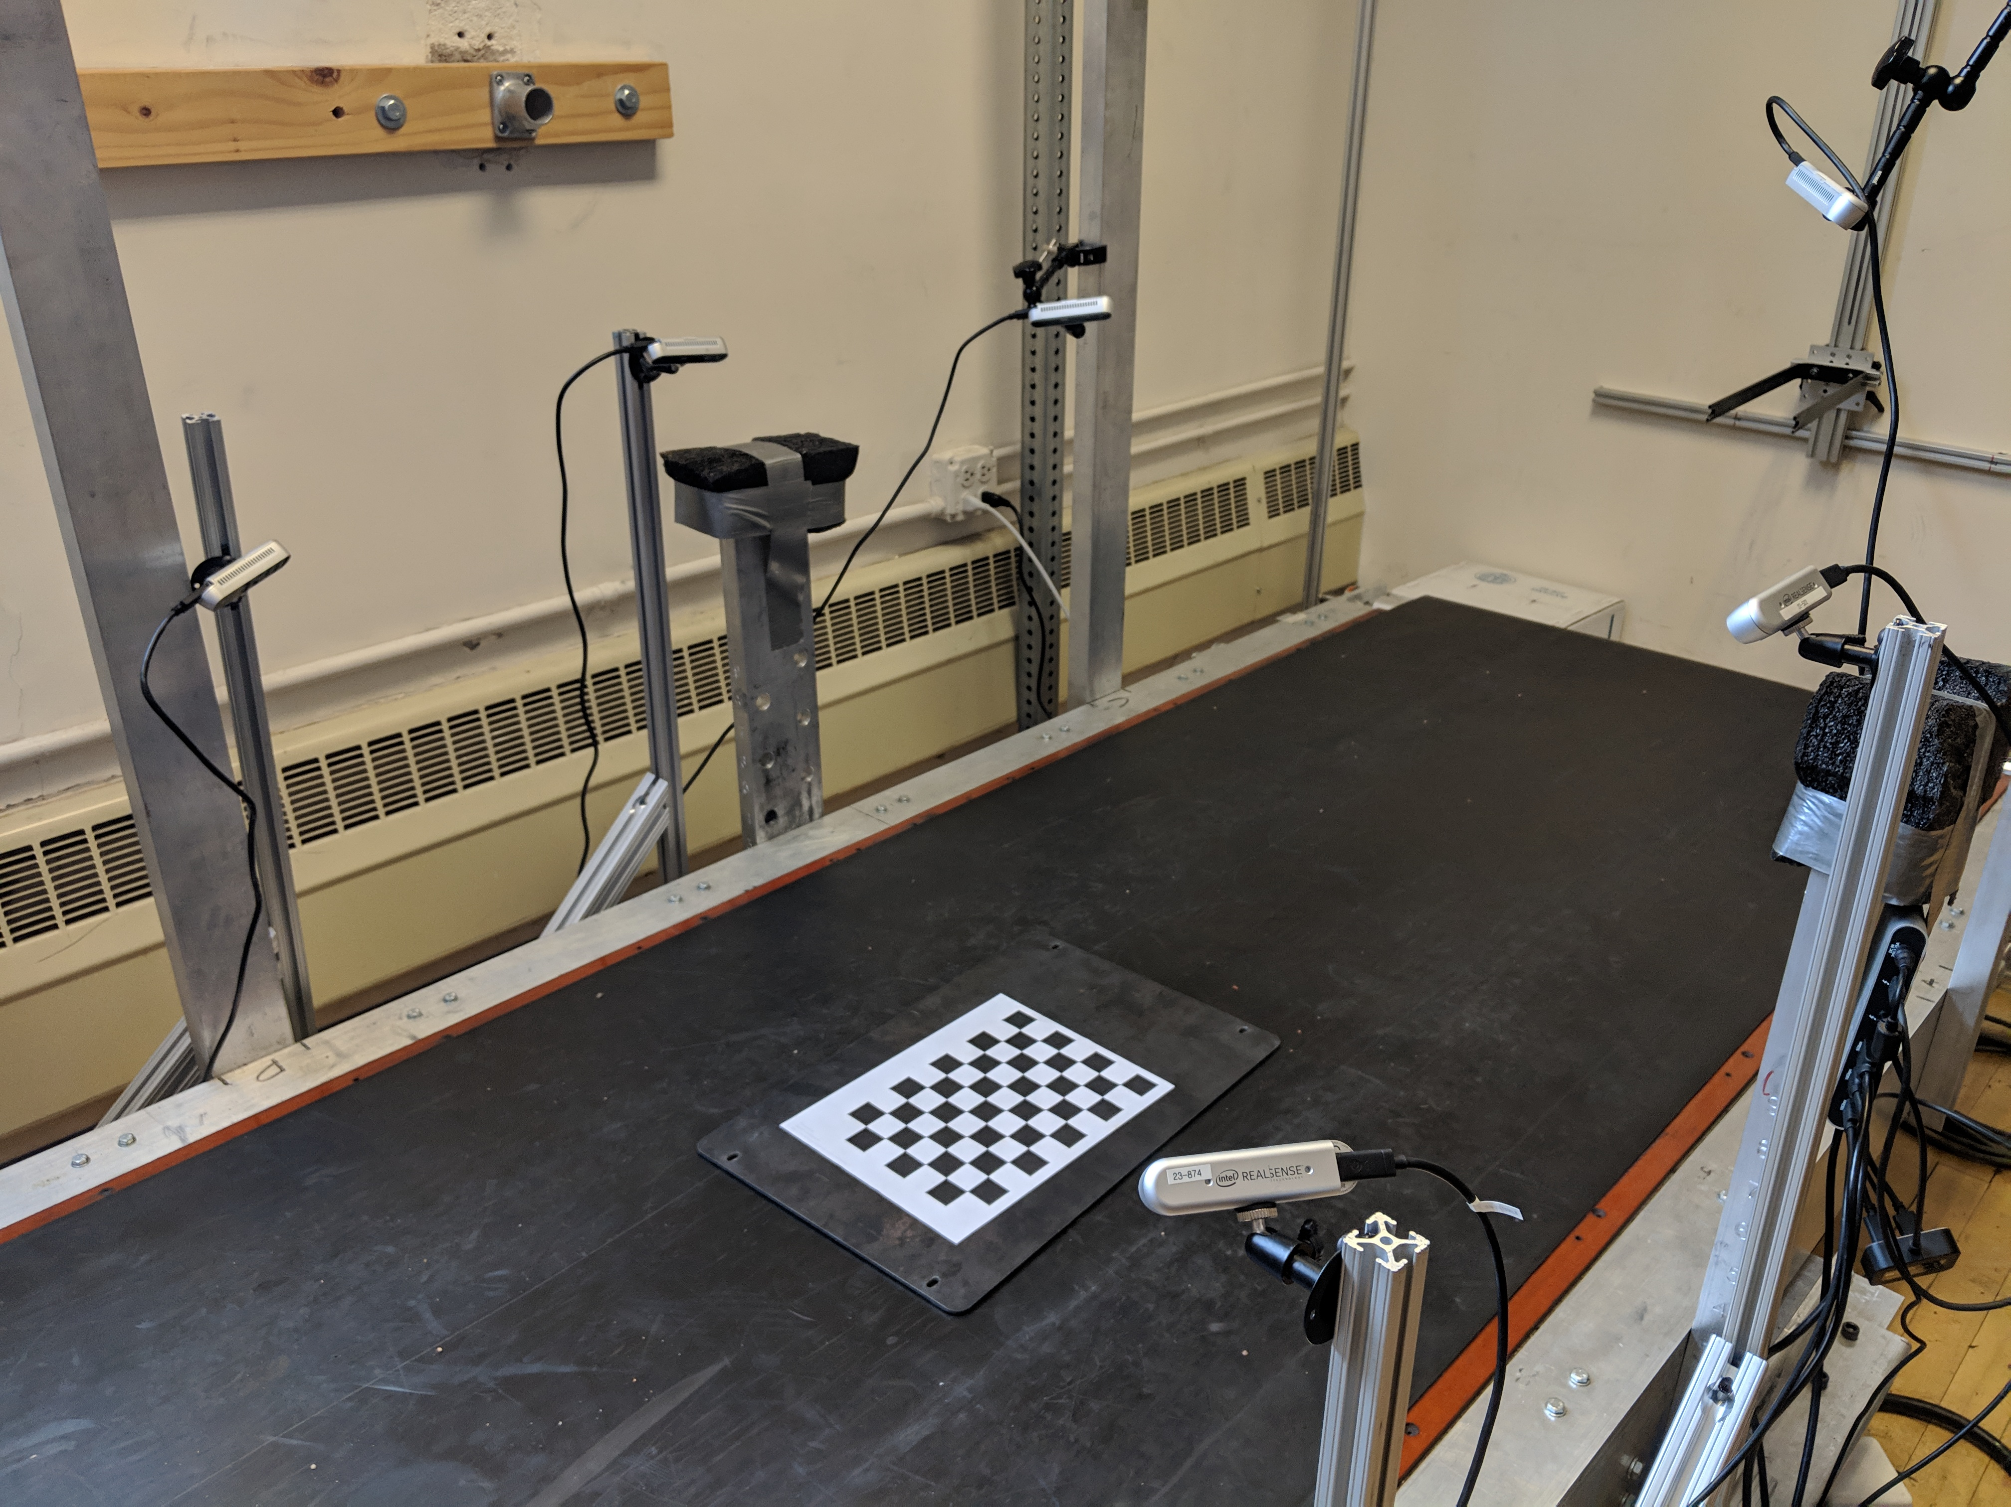

Figure 1: Capture setup of 6 Intel RealSense D415 Depth Cameras placed around a treadmill. The checkerboard shown was used to calibrate the cameras using the DynaMo package

## Statistical Shape Model Construction

Captured depth images were used to create a statistical shape model (SSM) representing changes in dynamic foot morphology. This was then used to reconstruct predicted foot shape along the gait cycle using subject’s demographic features. fig. 2 summarizes the SSM construction process.

All data was processed into a series of low-resolution point clouds with the DynaMo package to identify heel-strike to toe-off times. For each subject, a candidate heel-strike to toe-off event was manually identified across all captures by taking into account point cloud quality. For each event, point clouds were reconstructed by converting the depth images into full-resolution point clouds.

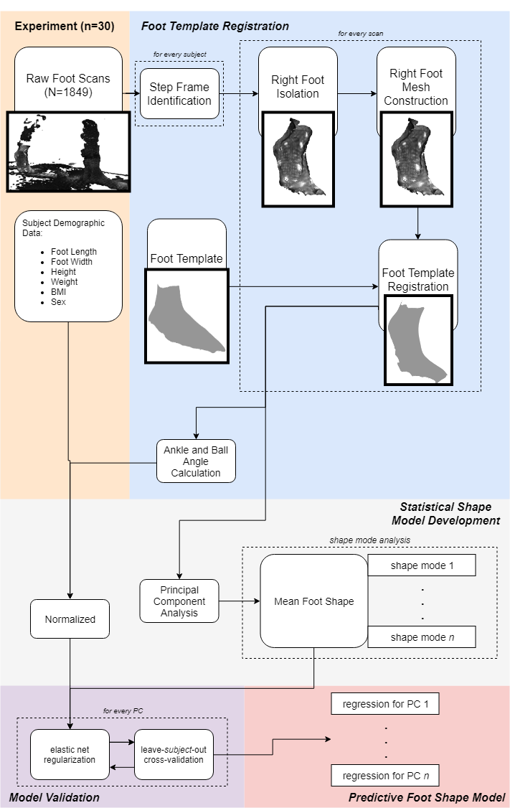

Figure 2: Flowchart of processing steps for statistical shape model creation

### Right Foot Isolation

The C++ implementation of the PointCloud Library (Rusu and Cousins 2011) was used to identify and isolate the right foot from the point set. First, the point clouds were downsampled with a voxel size of 3 mm to reduce required computing power. A RANSAC algorithm (Fischler and Bolles 1981) was used to identify the flat treadmill floor with a plane model, and remove it from the point cloud. Euclidean cluster extraction was then used to detect the point clusters that make up each foot. The total color value of each point cluster was used to identify the right foot from the left foot, as the left foot had a lower total color value due to the black sock. The left foot was then removed from the point cloud, leaving only the right foot for processing.

### Foot Scan Mesh Construction

Surface reconstruction was done through Meshlab (Cignoni et al. 2008). A surface mesh adds a topological layer interpreted from the point cloud. Point normals were calculated for the point cloud using the 10 nearest neighbors. An APSS Marching Cubes algorithm (Guennebaud and Gross 2007; Guennebaud, Germann, and Gross 2008) is then used with the point normals to estimate the surface from the point cloud and construct the foot scan mesh.

### Foot Template Registration

Every depth image and point cloud reconstruction for each frame was captured independently by the cameras. Therefore, the amount and location of points which represent the foot in the data are not consistent. In addition, the captured data may have holes in the surface representing the foot, which would be manifested in the surface reconstruction. Point cloud registration to a template can assist statistical analysis by reconstructing the subject data to a common template with a standardized number of points. A foot template was provided by collaborators Reed and Corner, and was derived from an average set of scans taken with a high-quality static 3D foot scanner (Reed, Ebert, and Corner 2013). The toes were smoothed into a single structure and parts of the upper shank removed to be better fit to the captured data, with a finalized structure of 29903 points. The overall registration process follows a two-step process: a rough alignment followed by a radial-basis function (RBF) fine alignment.

The registration process was first completed for each subject’s data with a foot scan mesh manually identified near mid-stance. A point-to-plane iterative-closest-point (ICP) algorithm (Chen and Medioni 1992) was used to roughly align the template foot to the scan mesh with the Open3D library (Zhou, Park, and Koltun 2018).

Corresponding points between both the scan mesh and the ICP-aligned template were found using a radial-search KD-Tree implemented in the Open3D library (Zhou, Park, and Koltun 2018). A subsetted scan and template were then created through the following process. Any points on the scan mesh which were not within 1 cm of a corresponding point on the aligned template were deleted; these points represented parts of the treadmill floor which were missed in the RANSAC identification and parts of the upper shank. Similarly, any points on the template not within 1cm of a corresponding point on the scan mesh were temporarily deleted from the template; these points correspond to those near holes in the scan mesh which would be refilled in later processing.

Thin-plate spline RBFs have been used to surface fit templates to scanned body shapes (Park and Reed 2015; Kim et al. 2016).

A first-pass RBF registration is done from the subsetted template and the subsetted scan using the GIAS2 package (Zhang, Hislop-Jambrich, and Besier 2016), with a thin-plate spline RBF used to fit the subsetted scan. Up to five iterations are done on the first-pass RBF registration process.

The first-pass registered RBF subsetted template is then appended with the points removed from the template during the subsetting process. This intermediate template represents the template fitted to the known scan data, with any unknown sections, representing holes in the scan data, taking the value of the template. However, the disparity between the known and unknown sections creates major steps in the morphed template not representative of the scan data.

A second-pass RBF registration is done from the ICP-aligned template to the intermediate template with the same parameters as the first-pass registration. This smooths out the unknown sections representing holes in the scan data with the surrounding known sections. The second-pass registered template is saved as the final registered template.

Following the registration of the mid-stance scan, the process is repeated both forwards and backwards in the scan sequence towards toe-off and heel-strike, respectively. In this iterative fashion, the previous scan’s registered template is used as the template for the following scan. During the iterative registration process, the RBF alignment is only conducted for one iteration for both the first-pass and second-pass to prevent over-fitting.

The registered templates are then compared against the initial scans to ensure they accurately represent the captured scan data. Comparisons are done by finding corresponding points between the scan data and the registered template, and calculating the root-mean-squared error (RMSE) between the corresponding points.

### Scan Alignment and Joint Angle Calculation

The template identifies certain vertices as anatomical landmarks. These landmark vertices were conserved through the registration process; they can therefore be used to identify the anatomical landmarks on the registered scans. The lateral malleolus, medial malleolus, lateral metatarsal, medial metatarsal, and 2nd phalange landmarks were taken from the template, while new landmark vertices for the lateral shank and medial shank were manually picked on the template.

Post-registration scans were aligned to a common coordinate frame based around the metatarsophalangeal (MTP) joint. The origin was defined as the point along the vector from the lateral metatarsal landmark to the medial metatarsal landmark which is orthogonal to the second phalange. From the origin, the x-axis was defined as pointing towards the medial metatarsal, the y-axis was defined as pointing towards the lateral metatarsal, and the z-axis was the cross-product of both x- and y-axes. This coordinate system is shown in fig. 3.

The MTP and ankle joint angles were calculated post-registration for each scan from the anatomical segments of the shank, midfoot, and phalanges.  
The shank center was defined as the center between the lateral shank and medial shank landmarks. The MTP center was defined as the center between the lateral metatarsal and medial metatarsal landmarks. The shank’s normal vector was defined as the cross-product of the vector from the shank center to the lateral malleolus, and the vector from the shank center to the medial malleolus. The midfoot’s normal vector was defined as the cross-product of the vector from the MTP center to the lateral malleolus, and the MTP center to the medial malleolus. The phalanges’ normal vector was defined as the cross product from the 2nd toe to the lateral metatarsal, and from the 2nd toe to the medial metatarsal.

The MTP joint angle was calculated as the acute angle between the phalanges’ normal vector and the midfoot’s normal vector. The ankle joint angle was calculated as the acute angle between the midfoot’s normal vector and the shank’s normal vector.

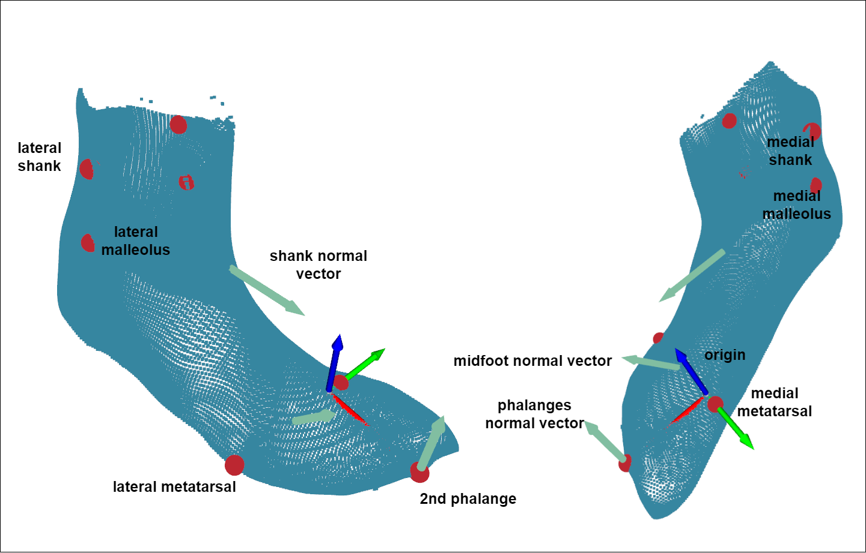

Figure 3: Anatomical landmarks, coordinate system, and vectors defining anatomical segments of a registered scan

### Principal Component Analysis

Principal component (PC) analysis is a dimensionality-reduction method commonly used to build statistical body shape models in digital human modelling, with applications for whole-body (Reed and Parkinson 2008; Park and Reed 2015) as well as foot shape models (Conrad et al. 2019; Stanković et al. 2020). The first PC represents an axis containing the largest variance in the dataset, and each subsequent PC describes the largest variance orthogonal to the previous component’s axis. Therefore, PCs allow for a new, smaller set of orthogonal variables to be defined which represent the variance in the dataset.

Let $N$ equal the number of total scans in the dataset, and $n$ equal the number of vertices in each registered scan. Each registered scan is represented as an $n×3$ array, with columns describing the x,y, and z locations of each vertex, respectively. Therefore, the entire dataset of registered scans is represented as a 3D $N×n×3$ array. This dataset was reshaped into a 2D $N×(n×3)$ array by flattening each scan.

The scikit-learn module (Pedregosa et al. 2011) was used to incrementally calculate the $(N-1)$ PCs of the reshaped dataset. The resultant PC model can be used to inverse transform an vector of length $(N-1)$ PC scores into a $(n×3)$ length vector, which can then be reshaped into a $n×3$ array representing a foot shape.

Each scan in the dataset is represented in the PC model with $n-1$ PC scores. All PC scores are centered around 0, which represents the mean foot scan of the dataset ($\overset{‾}{x}$). Each PC represents a shape mode in the SSM, where each score represents a deviation from the mean foot along the shape mode axis.

Not all shape modes are retained in the SSM, as the first few principal components may explain the majority of the variance. The number of PCs to explain 95%, 97.5% and 99.2% of the variance was calculated from the dataset. PC scores not retained are set to 0 when inverse-transforming the PC scores to foot shape.

### Predictive Model Development

Subject demographic data and calculated joint angles was incorporated into the SSM by developing multivariate linear regression models based on these features to predict each PC score, which can then be inverse-transformed into a foot shape. Subject demographic data and joint angles were normalized to aid in regression development. An elastic net regularization algorithm was run for each multivariate regression to calculate feature coefficients for each PC score’s regression. Normalized coefficients below 0.05 were not included in regression models due to their minimal influence on the predicted PC score.

The number of shape modes retained in the predictive model was tested by building models which predict the number of PCs that explain 95%, 97.5%, and 99.2% of the variance. Models were also built with all subject demographic features, and after removing highly cross-correlated subject features of height (correlated with foot length), weight (correlated to BMI and foot length), and gait cycle (correlated with ankle angle and ball angle).

### Model Validation

All models were validated for performance using leave-*p*-out cross-validation, where scans from each subject were set as the validation set, and models were trained on the remaining dataset.

Model performance was quantified with the root mean squared error of the predicted foot shape to the corresponding scan during validation. The predicted foot shape is rigidly aligned to the scan through a least-squares alignment; rigid-alignment preserves morphology by only rotating and translating the foot shape. For every point in the scan, the nearest vertex in the predicted foot shape found by searching a KD-tree of the foot shape. The distance between the two corresponding points is taken as the prediction error. The root mean squared error of these distances is calculated for every scan tested.

### Model Compilation

Following model validation, each PC’s regression was compiled into a custom Python function to predict foot shape based on subject demographic data through the gait cycle.

# Results

# References

Boppana, Abhishektha, and Allison P Anderson. 2019. “DynaMo: Dynamic Body Shape and Motion Capture with Intel RealSense Cameras.” *The Journal of Open Source Software* 4 (41). <https://doi.org/10.21105/joss.01466>.

Browning, Raymond C., Emily A. Baker, Jessica A. Herron, and Rodger Kram. 2006. “Effects of obesity and sex on the energetic cost and preferred speed of walking.” *Journal of Applied Physiology* 100 (2): 390–98. <https://doi.org/10.1152/japplphysiol.00767.2005>.

Chen, Yan, and Gerard Medioni. 1992. “Object modelling by registration of multiple range images.” *Image and Vision Computing* 10 (3): 2724–9. [https://graphics.stanford.edu/{~}smr/ICP/comparison/chen-medioni-align-rob91.pdf](https://graphics.stanford.edu/%7B~%7Dsmr/ICP/comparison/chen-medioni-align-rob91.pdf).

Cignoni, P., M. Callieri, M. Corsini, M. Dellepiane, F. Ganovelli, and G. Ranzuglia. 2008. “MeshLab: An open-source mesh processing tool.” *6th Eurographics Italian Chapter Conference 2008 - Proceedings*, 129–36.

Conrad, Bryan P., Michael Amos, Irene Sintini, Brian Robert Polasek, and Peter Laz. 2019. “Statistical shape modelling describes anatomic variation in the foot.” *Footwear Science* 11 (sup1): S203–S205. <https://doi.org/10.1080/19424280.2019.1606334>.

Fischler, Martin A., and Robert C. Bolles. 1981. “Random sample consensus: A Paradigm for Model Fitting with Applications to Image Analysis and Automated Cartography.” *Communications of the ACM* 24 (6): 381–95. <https://doi.org/10.1145/358669.358692>.

Giles, Eugene, and Paul H. Vallandigham. 1991. “Height Estimation from Foot and Shoeprint Length.” *Journal of Forensic Sciences* 36 (4): 13129J. <https://doi.org/10.1520/jfs13129j>.

Gordon, Claire C., Cynthia L. Blackwell, Bruce Bradtmiller, Joseph L. Parham, Patricia Barrientos, Stephen P. Paquette, Brian D. Corner, et al. 2014. “2012 Anthropometric Survey of U.S. Army Personnel: Methods and Summary Statistics.” Natick, MA: ARMY NATICK SOLDIER RESEARCH DEVELOPMENT AND ENGINEERING CENTER MA. <https://apps.dtic.mil/docs/citations/ADA611869>.

Guennebaud, Gaël, Marcel Germann, and Markus Gross. 2008. “Dynamic sampling and rendering of algebraic point set surfaces.” *Computer Graphics Forum* 27 (2): 653–62. <https://doi.org/10.1111/j.1467-8659.2008.01163.x>.

Guennebaud, Gaël, and Markus Gross. 2007. “Algebraic point set surfaces.” *Proceedings of the ACM SIGGRAPH Conference on Computer Graphics*. <https://doi.org/10.1145/1275808.1276406>.

Kim, K. Han, Karen S. Young, Yaritza Bernal, Abhishektha Boppana, Linh Q. Vu, Elizabeth A. Benson, Sarah Jarvis, and Sudhakar L. Rajulu. 2016. “A Parametric Model of Shoulder Articulation for Virtual Assessment of Space Suit Fit.” In *Proceedings of the 7th International Conference on 3D Body Scanning Technologies*, 201–7. Lugano, Switzerland. <https://doi.org/10.15221/16.201>.

Park, Byoung Keon, and Matthew P. Reed. 2015. “Parametric body shape model of standing children aged 3–11 years.” *Ergonomics* 58 (10): 1714–25. <https://doi.org/10.1080/00140139.2015.1033480>.

Pedregosa, Fabian, Ron Weiss, Matthieu Brucher, Gaël Varoquaux, Alexandre Gramfort, Vincent Michel, Bertrand Thirion, et al. 2011. “Scikit-learn: Machine Learning in Python.” *Journal of Machine Learning Research* 12 (85): 2825–30. <https://doi.org/10.1145/2786984.2786995>.

Reed, Matthew P, Sheila M Ebert, and Brian D Corner. 2013. “Statistical Analysis to Develop a Three-Dimensional Surface Model of a Midsize-Male Foot.” October.

Reed, Matthew P., and Matthew B. Parkinson. 2008. “Modeling variability in torso shape for chair and seat design.” *Proceedings of the ASME Design Engineering Technical Conference* 1 (PARTS A AND B): 561–69. <https://doi.org/10.1115/DETC2008-49483>.

Rusu, Radu Bogdan, and Steve Cousins. 2011. “3D is here: Point Cloud Library (PCL).” In *Proceedings - Ieee International Conference on Robotics and Automation*. Shanghai, China. <https://doi.org/10.1109/ICRA.2011.5980567>.

Stanković, Kristina, Toon Huysmans, Femke Danckaers, Jan Sijbers, and Brian G. Booth. 2020. “Subject-specific identification of three dimensional foot shape deviations using statistical shape analysis.” *Expert Systems with Applications* 151 (August): 113372. <https://doi.org/10.1016/j.eswa.2020.113372>.

Zhang, Ju, Jacqui Hislop-Jambrich, and Thor F. Besier. 2016. “Predictive statistical models of baseline variations in 3-D femoral cortex morphology.” *Medical Engineering and Physics* 38 (5): 450–57. <https://doi.org/10.1016/j.medengphy.2016.02.003>.

Zhou, Qian-Yi, Jaesik Park, and Vladlen Koltun. 2018. “Open3D: A Modern Library for 3D Data Processing.” *arXiv:1801.09847*. <http://arxiv.org/abs/1801.09847>.